**PRoM128: Project Management System**

**for the CMSC 128 course using the Laravel Framework**

**in Agile Development. Gabriel Luis G. Borjal** Institute of Computer Science University of the Philippines, Los Banos, Laguna gborjal01@gmail.com

**ABSTRACT**

The course CMSC 128, Introduction to Software Engineering, requires its students to analyze and model systems; develop alternative solutions; and, implement, test, and validate system designs; which also means that there are multiple projects in progress throughout the semester from different classes that follow different project life cycle principles. Due to this, professors handle the progress of multiple projects that, also, require input from multiple individuals or teams. The aim of this paper is to create a project management system that will help ease monitoring progress by professors and students on different projects and introduce an emulation of software development. A web-based project management system wherein both the professor and student can monitor and manage projects progress in real time will increase the efficiency and productivity of projects of each class. The success of the system will be assessed through a survey that will be given to the CMSC 128 students and professors where ease-of-use, effectiveness, and production rate will be the main scope for evaluation.

**INTRODUCTION**

CMSC 128, Introduction to Software Engineering, has, as its objectives, its students learn to analyze and model systems; develop alternative solutions; and, implement, test, and validate system designs with a project in the form of a software as its final output [1]. In the recent semesters along the progression of the course, models of project life cycle principles are introduced; as well as projects being done by each laboratory class. Each student in a lab gets an assignment of role, such as, project manager (PM), team leader (TL), and developer (Dev). Projects of laboratory classes are organized into these roles as a simulation of software development.

An inexistence of a system where CMSC 128 projects that should be handled and monitored gives rise to an unorganized and difficult manner in managing and monitoring of projects for students, professors, and instructors. Project aspects like project scheduling, assigning of tasks, documentation, quality assurance, integrations, and communication are not closely observed. As part of the simulation in the early stages of software development, PMs and TLs should be able to identify deliverables, freely, on deadlines set by the professor or instructor, but instead, deliverables come from the professors. Even with the roles given, handling human resource by allocating tasks by TLs to team Devs is difficult where there are no records even specifications of a task. This delays completion of tasks and chains the lack of communication between teams, especially those that needs output from other teams, and within the team, as well. Quality is being compromised, as well, since there is no focus in reviewing of tasks done. Lastly, with the number or laboratory sections, lecturers and laboratory instructors would, also, have difficulty in keeping a close eye on multiple class project progress with all those aspects lacking.

The solution is to create an automated project management system (PMS) tailored for the CMSC 128 class and professors. With PMS, issues with time, quality, human resource, integration, and documentation management will be, more or less, addressed. The system will be a web-based PMS with Laravel 5.1 as its php framework. The system will be using node.js as server and postgres.sql as its database. Adapting the system will aid in managing, monitoring and evaluating projects from classes of CMSC 128 while giving students an opportunity in experiencing a new tool used mainly on project management and teaching them a system to work on responsibly and efficiently.

**RELATED WORK**

In general, what makes a project unique is its set of requirements. According to Kathy Schwalbe (2013), each differ based on the need and is constrained differently by its scope, time and cost goals also known as *the triple constraint* [2].Due to frequent changes, the task of planning accurately becomes a challenge which is a result of feedback responses, nonlinear relationships, and accumulation of project progress and resources [3].

Lyneis and Ford discusses system dynamics in project management systems [3]. Munns and Bjeirmi identifies reasons for the success or a failure of a project [4]. SAMÁKOVÁ, KOLTNEROVÁ and RYBANSKÝ (2012) focused on the importance of project communication management [5]. There are a few software being used by companies in the industry, which is even considered in the study of Birgul Kutlu, et al (2014), which used the analytic hierarchy process method in selecting project management software [6].

Arvind Sathi, et al (1986), created an intelligent project management system called Callisto [7]. Anne-Mai Aadamsoo’s (2010), creates a web based project management system and used an issue tracking system [8]. A similar research was done by James Goodhue (2010), where he implemented a web-based project management in the New Zealand Construction Industry [9].

**METHODOLOGY**

ProM128 will be implemented with the Laravel 5.1 framework and postgre.sql as its database and will adapt the agile development. Laravel is chosen for its security, lightweight, and rate of developing. Node.js will, also, be used as the server for its lightweight and efficiency in handling data-intensive real-time applications.

With the nature of Software development, the user roles are divided into Professor, Project Manager, Team Leader, and Developers. 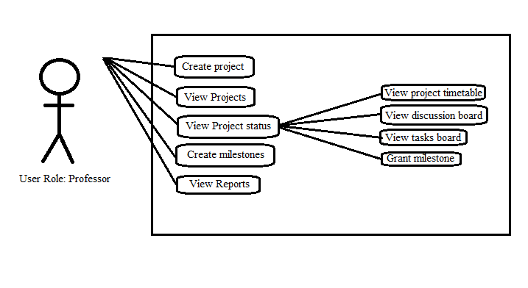Fig 1. Use Case diagram of a Professor with ProM128.

In Fig 1, the privilege of project specifications, and milestones comes from professors. To closely monitor a project’s progress professors are able to view the timetable, discussions and tasks of a project.

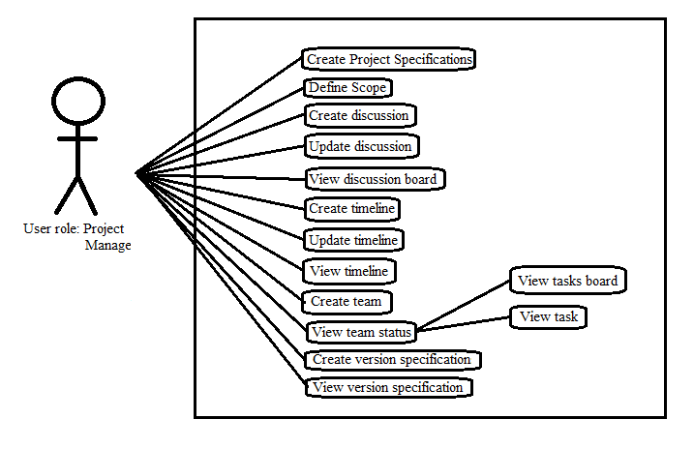Fig 2. Use Case diagram of a Project Manager with ProM128.

In fig 2, Project managers (PM) are able to identify and define the project’s scope, maintain the timetable, manage teams. PMs are given the privilege and responsibility of maintain the versions and integrations. PMs are, also, able to create and maintain discussions within the project as well as the monitoring of tasks.

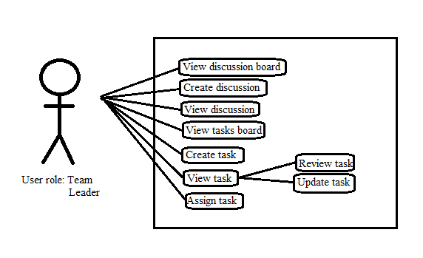Fig 3. Use Case diagram of a Team Leader with ProM128.

In fig 3, Team Leaders (TL) are able to create, assign, and review tasks of team members. TLs are, also, able to create and maintain discussions

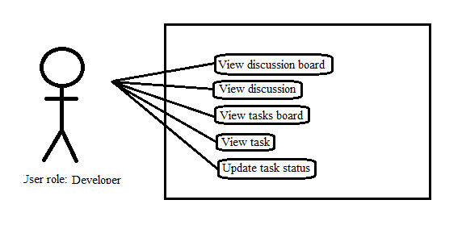

Fig 4. Use Case diagram of a Developer with ProM128.

In fig 4, Developers (Devs) have the least privilege in that the discussion board, tasks board, and assigned tasks are the only accessible functions in the system.

**EVALUATION**

The implementation will be assessed with a survey given to the professors, laboratory instructors and students who will be using ProM128. The survey will make use of criteria which are derived in the study of Birgul Kutlu, et al (2014). The criteria groups that will evaluate the system will be the cost, user friendliness, and tool maturity. The range of values will be within 0-10, with 10 being the highest [6].

|  |  |
| --- | --- |
| **Criteria** | **Area of evaluation** |
| Cost for User | Hardware Infrastructure  Implementation  Maintenance |
| User Friendliness | Multidimensional Reporting  User Responsiveness |
| Tool Maturity | Maintainability  Functionality  Documentation quality  Customization |

Table 1. Criteria groups and specific areas of evaluation [6].

Evaluation of Prom128 will adapt Birgul Kutlu’s, et al (2014) [6] formulated criteria as seen in Table 1 which shows specific areas of used as evaluation for PMS.

**TIMELINE OF ACTIVITIES**

|  |  |
| --- | --- |
| **Activity** | **Time Allotted** |
| Learning of technologies   * Laravel 5.1 * Node.js * Postgre.sql   Setup database architecture  Create node.js server  Create site functionalities   * Create, login, and update user function * Admin side   + Site maintainance   + Admin functions * User side   + Professor   + Project Manager   + Team Leader   + Developer | 1 month  2 weeks  2 weeks  2 months  1 week  2 weeks  1 month and 1 week |

**REFERENCES**

1. CMSC 128: Introduction To Software Engineering. Retrieved on 06 November 2015 from http://www.ics.uplb.edu.ph/courses/ugrad/cmsc128

2. Kathy Schwalbe (2013). Management of Information Technology Projects. Book. Cengage Learning Asia Pte Ltd (Philippine Branch).

3. James M. Lyneis and David N. Ford (2007). System dynamics applied to project management: a survey, assessment, and directions for future research. Journal. Wiley InterScience. Retrieved on 23 October 2015 from http://onlinelibrary.wiley.com/doi/10.1002/sdr.377/pdf

4. A K Munns and B F Bjeirmi (1996). The Role of project management in achieving project success. Journal. International Journal of Project management Vol. 14. Retrieved on 23 October 2015 from https://notendur.hi.is/vio1/The_role_of_project_management_in_achieving_project_success.pdf

5. Jana SAMÁKOVÁ, Kristína KOLTNEROVÁ, and Rudolf RYBANSKÝ. Project Communication in Functions, Process and Project-Oriented Industrial Companies. Research paper.

SLOVAK UNIVERSITY OF TECHNOLOGY IN BRATISLAVA. Retrieved on 23 October 2015 from http://www.mtf.stuba.sk/docs/doc/casopis_Vedecke_prace/SN/Samakova_Koltnerova_Rybansky.pdf

6. Birgul Kutlu, et al (2014). Project Management Software Selection Using Analytic Hierarchy Process Method. Journal. International Journal of Applied Science and Technology. Retrieved on 23 October 2015 from

http://www.researchgate.net/publication/271271488_Project_Management_Software_Selection_Using_Analytic_Hierarchy_Process_Method

7. Arvind Sathi, et al (1986). Callisto: An Intelligent Project Management System. Journal. AI Magazine Volume 7 Number 5. Retrieved on 23 October 2015 from http://www.aaai.org/ojs/index.php/aimagazine/article/view/564

8. Anne-Mai Aadamsoo (2010). Web Based Project Management System. Research paper. Retrieved on 23 October 2015 from http://www.theseus.fi/bitstream/handle/10024/16996/Aadamsoo_Anne-Mai.pdf

9. James Goodhue (2010). Implementing Web-Based Project Management system in the New Zealand. Technical Report. Retrieved on 27 October 2015 from http://unitec.researchbank.ac.nz/handle/10652/1786.